Battle Legends – A Java Inheritance-Based Mythology Role-Playing Game

Project Scenario:
In ancient Bharat, during the age of epic wars and divine beings, six mythological heroes rise to protect righteousness (Dharma) and restore peace. The heroes include:
- Arjuna – Master archer of the Pandava clan
- Karna – Invincible warrior with divine armor
- Krishna – Supreme deity guiding warriors and strategizing battles
- Bhima – Mighty Pandava known for immense strength
- Dhanvantari – Divine healer of gods
- Hanuman – Devotee with unmatched strength and loyalty
The player takes the role of one of these heroes and battles against randomly chosen opponents in the Kurukshetra Arena of Legends. Each hero has unique attacks and defenses inspired by their mythological powers.
Every battle is unpredictable — strength, strategy, and divine blessings determine the outcome. Only the hero who masters their abilities can become the ultimate legend of Bharat.

Objective
The main goal of this project is to:
- Demonstrate the concept of inheritance in Java.
- Show how multiple subclasses can inherit properties and behaviors from a single base class.
- Illustrate method overriding, where each subclass modifies inherited behavior to suit its unique role.
- Provide an interactive, fun, and text-based role-playing game environment.

Key Concepts
- Inheritance: All hero types inherit from the base class Character.
- Method Overriding: Subclasses provide their own implementation of attack() and defend() methods.
- Abstraction: The base class Character is abstract and defines common templates for all heroes.
- Randomization: Random class is used to assign attack power, making battles unpredictable.
- User Interaction: Scanner class allows players to choose heroes, enter names, and continue or quit rounds.
Code for Battle Legends Game:
import java.util.*;

abstract class Character {
String name;
Character(String name) { this.name = name; }
abstract String attack();
abstract String defend();
}

// ===== Mythological Character Classes =====
class Arjuna extends Character {
Arjuna(String n){ super(n); }
String attack(){ return name + " shoots arrows from Gandiva 🎯"; }
String defend(){ return name + " blocks with divine armor 🛡️"; }
}

class Karna extends Character {
Karna(String n){ super(n); }
String attack(){ return name + " fires celestial arrows 🌟"; }
String defend(){ return name + " deflects attacks with Bhargava armor 🛡️"; }
}

class Krishna extends Character {
Krishna(String n){ super(n); }
String attack(){ return name + " strikes with Sudarshan Chakra 🔱"; }
String defend(){ return name + " creates magical illusions ✨"; }
}

class Bhima extends Character {
Bhima(String n){ super(n); }
String attack(){ return name + " smashes silently with mace 🗡️"; }
String defend(){ return name + " dodges using immense strength 💨"; }
}

class Dhanvantari extends Character {
Dhanvantari(String n){ super(n); }
String attack(){ return name + " emits divine healing light 🌸"; }
String defend(){ return name + " heals instantly 💖"; }
}

class Hanuman extends Character {
Hanuman(String n){ super(n); }
String attack(){ return name + " smashes with mighty strength 💥"; }
String defend(){ return name + " absorbs all damage with divine power 🦁"; }
}

// ===== Main Game Class =====
public class BattleLegends {
public static void main(String[] args) {
Scanner sc = new Scanner(System.in);
Random rand = new Random();

System.out.println("🌟 WELCOME TO ⚔️ BATTLE LEGENDS – INDIAN MYTHOLOGY EDITION 🌟");
System.out.print("Enter your hero name: ");
String playerName = sc.nextLine();

String[] heroTypes = {
"Arjuna 🎯",
"Karna 🌟",
"Krishna 🔱",
"Bhima 🗡️",
"Dhanvantari 💖",
"Hanuman 💥"
};

// Player selects their own type
System.out.println("\nChoose your hero type:");
for (int i = 0; i < heroTypes.length; i++)
System.out.println((i+1) + "️⃣ " + heroTypes[i]);
int playerChoice = 0;
while (true) {
System.out.print("Enter hero type (1–6): ");
if (sc.hasNextInt()) {
playerChoice = sc.nextInt();
if (playerChoice >= 1 && playerChoice <= 6) break;
else System.out.println("❌ Invalid choice. Please enter a number between 1 and 6.");
} else {
System.out.println("❌ Invalid input. Please enter a number.");
sc.next(); // clear invalid input
}
}
sc.nextLine(); // clear buffer

// Player selects enemy type
System.out.println("\nChoose your enemy's type:");
for (int i = 0; i < heroTypes.length; i++)
System.out.println((i+1) + "️⃣ " + heroTypes[i]);
int enemyChoice = 0;
while (true) {
System.out.print("Enter enemy type (1–6): ");
if (sc.hasNextInt()) {
enemyChoice = sc.nextInt();
if (enemyChoice >= 1 && enemyChoice <= 6) break;
else System.out.println("❌ Invalid choice. Please enter a number between 1 and 6.");
} else {
System.out.println("❌ Invalid input. Please enter a number.");
sc.next(); // clear invalid input
}
}
sc.nextLine(); // clear buffer

// Assign character instances based on selections
Character player = switch (playerChoice) {
case 1 -> new Arjuna(playerName);
case 2 -> new Karna(playerName);
case 3 -> new Krishna(playerName);
case 4 -> new Bhima(playerName);
case 5 -> new Dhanvantari(playerName);
case 6 -> new Hanuman(playerName);
default -> throw new IllegalStateException("Unexpected value: " + playerChoice);
};

String enemyName = heroTypes[enemyChoice - 1].split(" ")[0]; // e.g., "Arjuna" from "Arjuna 🎯"
Character enemy = switch (enemyChoice) {
case 1 -> new Arjuna(enemyName);
case 2 -> new Karna(enemyName);
case 3 -> new Krishna(enemyName);
case 4 -> new Bhima(enemyName);
case 5 -> new Dhanvantari(enemyName);
case 6 -> new Hanuman(enemyName);
default -> throw new IllegalStateException("Unexpected value: " + enemyChoice);
};

System.out.println("\nYou have chosen: " + player.getClass().getSimpleName() + " (" + player.name + ")");
System.out.println("Enemy: " + enemy.getClass().getSimpleName() + " (" + enemy.name + ")");

System.out.println("\n⚔️ " + player.name + " vs " + enemy.name + " ⚔️");
System.out.println("🔥 Let the mythological battle begin! 🔥");

int pScore = 0, eScore = 0;
int round = 1;

while (round <= 5) {
System.out.println("\n🌪️ Round " + round + " begins!");
System.out.println(player.attack());
System.out.println(enemy.defend());
System.out.println(enemy.attack());
System.out.println(player.defend());

int p = rand.nextInt(50) + 1;
int e = rand.nextInt(50) + 1;
System.out.println("\n🎲 Power — " + player.name + ": " + p + " | " + enemy.name + ": " + e);

if (p > e) {
System.out.println("🏆 " + player.name + " wins this round!");
pScore++;
} else if (e > p) {
System.out.println("💀 " + enemy.name + " dominates this round!");
eScore++;
} else {
System.out.println("🤝 Draw! Both heroes fought equally!");
}

System.out.print("\n👉 Do you want to continue to the next round? (y/n): ");
String choice = sc.nextLine().trim().toLowerCase();
if (!choice.equals("y")) {
System.out.println("\n🛑 You decided to quit early!");
break;
}
round++;
}

System.out.println("\n🏁 FINAL SCORE → " + player.name + ": " + pScore + " | " + enemy.name + ": " + eScore);
System.out.println("======================================");

if (pScore > eScore)
System.out.println("🎉 Victory! " + player.name + " becomes a mythological legend!");
else if (eScore > pScore)
System.out.println("😢 " + enemy.name + " defeats you. Train harder!");
else
System.out.println("🤝 It's a tie! Both heroes are equally powerful!");

System.out.println("\n🍀 Thanks for playing Battle Legends – Mythology Edition!");
sc.close();
}
}
Input and Output:
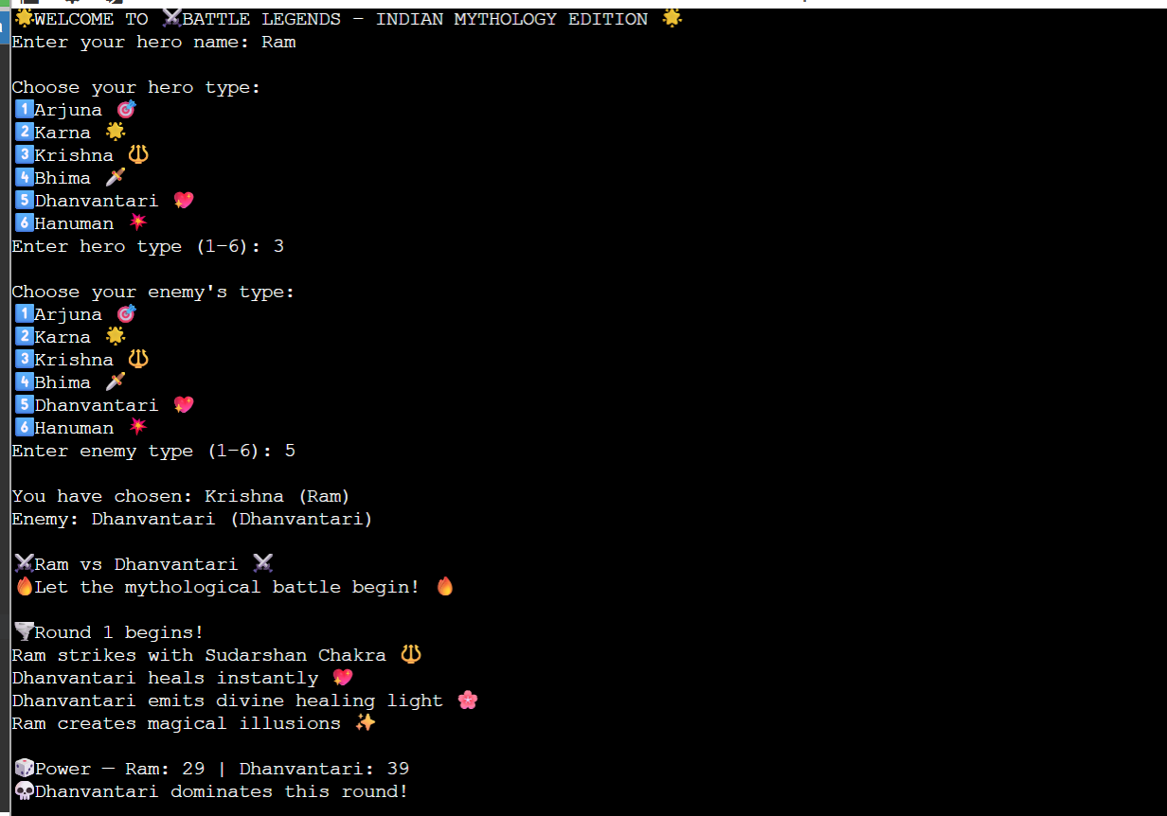

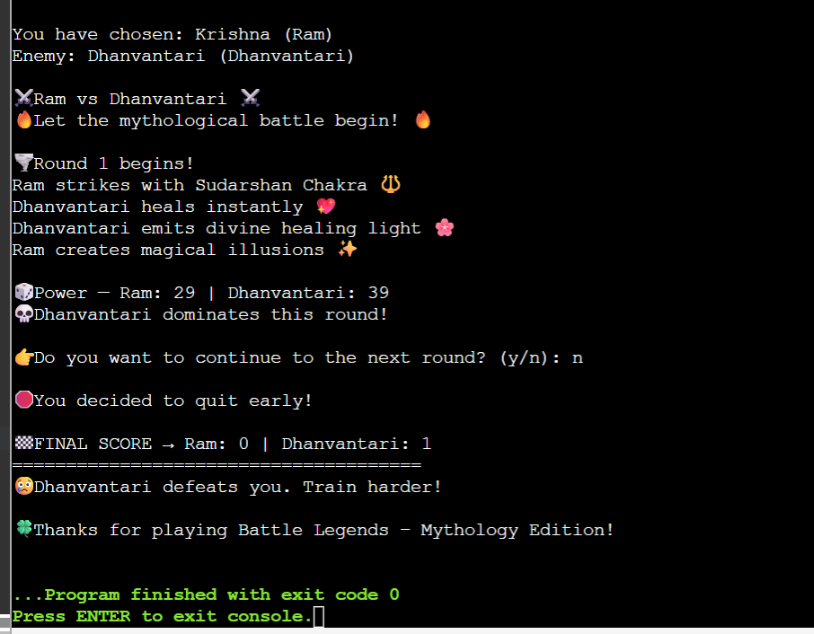
Explanation of Code:
Battle Legends – Indian Mythology Edition is a Java-based console game set in ancient Bharat, during an era when epic wars and divine beings shaped the fate of the world. Players step into the Kurukshetra Arena of Legends, choosing from six legendary heroes — Arjuna, Karna, Krishna, Bhima, Dhanvantari, and Hanuman — each embodying unique mythological abilities and virtues rooted in Dharma.
Every battle tests the hero’s strength, strategy, and divine blessings. Arjuna commands celestial archery, Karna wields invincible armor, Krishna uses divine wisdom and illusions, Bhima relies on brute strength, Dhanvantari heals with divine energy, and Hanuman channels unmatched devotion and power. The game’s combat system uses random power generation to simulate the unpredictability and divine intervention of mythological warfare.
Through multiple rounds of combat, the player faces off against chosen or random opponents. Victory depends not only on raw strength but also on the will to protect righteousness. The ultimate goal is to triumph in the arena and become the Eternal Legend of Bharat, symbolizing the triumph of light, valor, and Dharma.

